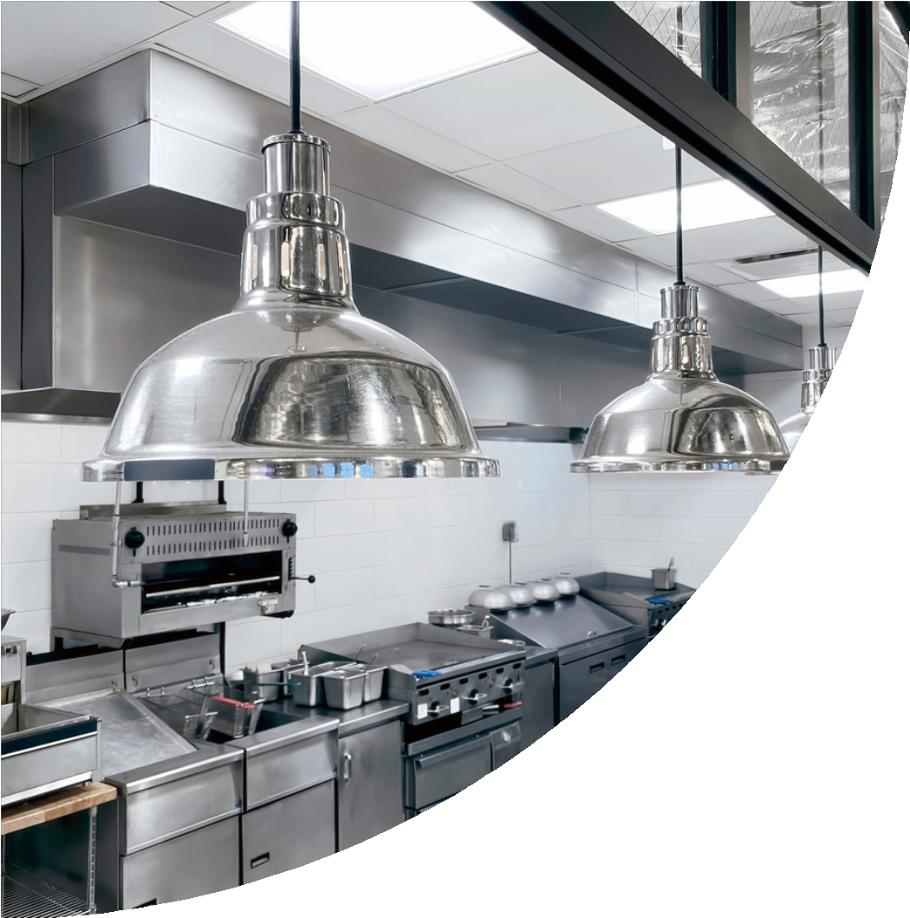


The Leading Manufacturer & Exporter Of All Type Of Food Processing Machinery

www.jksengworks.com www.chapatimaker.in www.rotimakingmachine.in


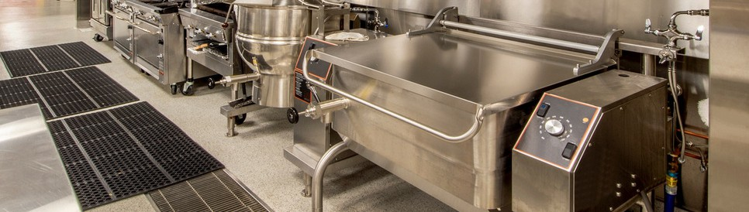
Our Company

15+
Years Of Experience

920+
Overseas Customers

2600+

Total Customers

We, “JK’S Engineering Works (India)” Established In The Year 2008, Are Sole Proprietor Firm Recognized As a Reputed Leading Manufacturer & Exporter a Comprehensive Assortment Of Automatic Chapati / Roti / Pita Bread / Arabic Kuboos/ Tortilla / Paratha / Poori Related Machinery.

90+

Team









Page 02
Experienced R 5 D
Department
Large Production
Capacity
Large
Product Line
Good Financial Position 5
TQM

Automatic Roti/Chapati Making Machine (JK-1312)

What this Machine Can Make
Chapati - Roti-Pita Bread - Arabic Kuboos-Tortilla - Paratha-Pori.
Electrical Specification

Machine Specification
Power | 1.5 KW
Voltage | 230 V / 50 Hz / Single Phase ( Can Be Customized According To Country- Wise Compatibility )

Machine Capacity | Upto 1050 Pc/Hour
Size Of Roti / Chapati | 2 Inch To 9 Inch (Adjustable)
Thickness Of Roti / Chapati | 1 mm to 8 mm (Adjustable)
Speed Of Machine | Fixed
Power Consumption | 1 Unit/Hour Approx.
Machine Size & Weight

Machine Dimension | 61x30x56 Inches
Weight | 440 kg.

Durable
Machine Features
Easy to Operate Easy to Clean Corrosion Resistant

Technical Specification


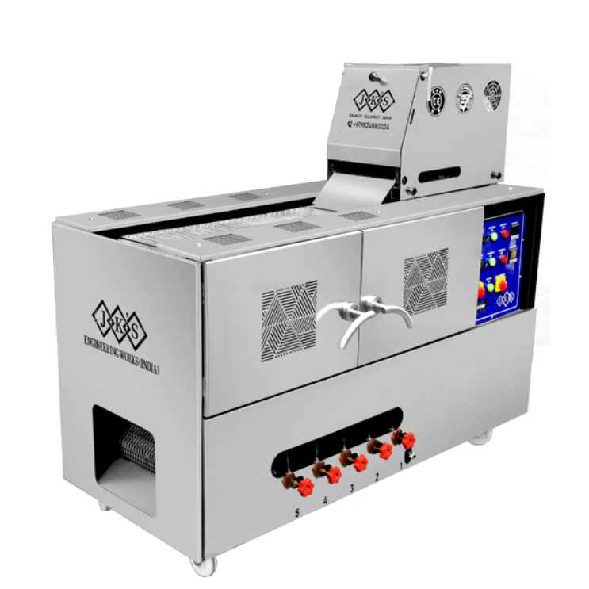
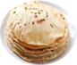
The Machine Body Are Manufactured in Stainless Steel 304 (Food Graded Material.)
All The Mechanical Parts Of The Machines Are Made Up Of Aluminium Material. (Food Graded Material.) Thickness Adjustment Facility Is Provided.
There Is Castle Wheel (With Brake System) Installed For The Easy Movement Of The Machine. All Electric PLC Parts of Schneider Electric. (Made In Indonesia)
Internationally Standard Branded Electrical Panel Accessories. Electric Motor 0.5 HP (2 Nos)
Warm Gear Box (Made In Italy)
The Roasting Will Be Done On a Three Layer Conveyor Belt.
All Safety Features Available In Machine as Per Global Euro Standard

Page 03

Automatic Roti/ Chapati Making Machine (JK-0202)

What this Machine Can Make
Chapati - Roti - Pita Bread - Arebic Kubos - Tortilla - Paratha - Pori

Machine Specification
Electrical Specification
Machine Capacity | Upto 500 Pc/Hour
Size Of Roti / Chapati | 2 Inch To 7 Inch (Adjustable)
Thickness Of Roti / Chapati | 1 mm to 8 mm (Adjustable)
Speed Of Machine | Fixed
Power Consumption | 1 Unit/Hour Approx

Power | 1.5 KW
Voltage | 230 V / 50 Hz / Single Phase ( Can Be Customized According To Country- Wise Compatibility )

Machine Size & Weight
Machine Features

Durable
Machine Dimension | 51x21x50 Inches
Weight | 270 kg.

Easy to Operate Easy to Clean Corrosion Resistant
Technical Specification

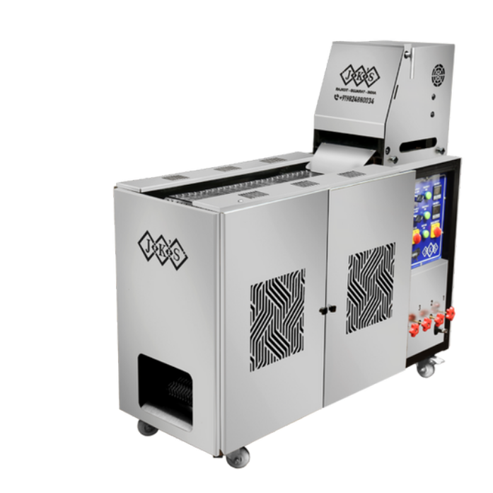
The Machine Body Are Manufactured in Stainless Steel 304 (Food Graded Material.)
All The Mechanical Parts Of The Machines Are Made Up Of Aluminium Material. (Food Graded Material.) Thickness Adjustment Facility Is Provided.
There Is Castle Wheel (With Brake System) Installed For The Easy Movement Of The Machine. All Electric PLC Parts of Schneider Electric. (Made In Indonesia)
Internationally Standard Branded Electrical Panel Accessories. Electric Motor 0.5 HP (1 Nos)
Warm Gear Box (Made In Italy)
The Roasting Will Be Done On a Three Layer Conveyor Belt.
All Safety Features Available In Machine as Per Global Euro Standard

Page 04

Roti/Chapati Pressing Machine With Roasting Unit (JK-2001)

What this Machine Can Make
Chapati - Roti - Pita Bread - Arebic Kubos - Tortilla - Paratha - Pori

Machine Specification
Electrical Specification
Machine Capacity | Upto 850 Pc/Hour
Size Of Roti / Chapati | 2 Inch To 9 Inch (Adjustable)
Thickness Of Roti / Chapati | 1 mm to 3 mm (Adjustable)
Speed Of Machine | Drive System (Adjustable)
Power Consumption | 1 Unit/Hour Approx

Power | 1.5 KW
Voltage | 230 V / 50 Hz / Single Phase ( Can Be Customized According To Country- Wise Compatibility )

Machine Size & Weight
Machine Features

Durable
Machine Dimension | 61x18x54 Inches
Weight | 195 kg.

Easy to Operate Easy to Clean Corrosion Resistant
Technical Specification

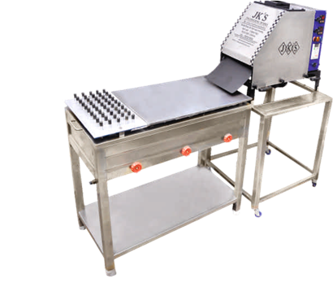
The Machine Body Are Manufactured in Stainless Steel 304 (Food Graded Material.)
All The Mechanical Parts Of The Machines Are Made Up Of Aluminium Material. (Food Graded Material.) Thickness Adjustment Facility Is Provided.
There Is Castle Wheel (With Brake System) Installed For The Easy Movement Of The Machine. All Electric PLC Parts of Schneider Electric. (Made In Indonesia)
Internationally Standard Branded Electrical Panel Accessories. Electric Motor 0.5 HP (1 Nos)
Warm Gear Box (Made In Italy)
The Roasting Will Be Done Manual Roasting Unit (Tava)
All Safety Features Available In Machine as Per Global Euro Standard

Page 05

Roti/ Chapati Pressing Machine (JK-0407)

What this Machine Can Make
Chapati - Roti - Pita Bread - Arebic Kubos - Tortilla - Paratha - Pori
Electrical Specification

Machine Specification

Machine Capacity | Upto 850 Pc/Hour
Size Of Roti / Chapati | 2 Inch To 10 Inch (Adjustable)
Thickness Of Roti / Chapati | 1 mm to 8 mm (Adjustable)
Speed Of Machine | Drive System (Adjustable)
Power Consumption | 1 Unit/Hour Approx
Machine Size & Weight

Machine Dimension | 25x13x22 Inches
Weight | 70 kg.

Power | 1.5 KW
Voltage | 230 V / 50 Hz / Single Phase ( Can Be Customized According To Country- Wise Compatibility )

Durable
Machine Features
Easy to Operate Easy to Clean Corrosion Resistant

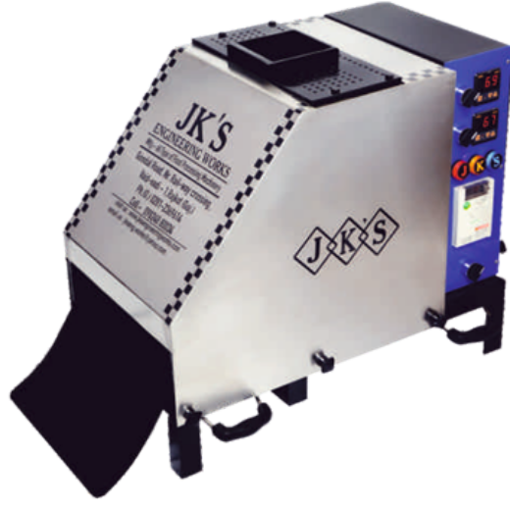
Technical Specification
The Machine Body Are Manufactured in Stainless Steel 304 (Food Graded Material.)
All The Mechanical Parts Of The Machines Are Made Up Of Aluminium Material. (Food Graded Material.) Thickness Adjustment Facility Is Provided.
All Electric PLC Parts of Schneider Electric. (Made In Indonesia) Internationally Standard Branded Electrical Panel Accessories. Electric Motor 0.5 HP (1 Nos)
Warm Gear Box (Made In Italy)
All Safety Features Available In Machine as Per Global Euro Standard

Page 06

Automatic Dough Machine (JK-1107)
Ball/ Dough Divider

What this Machine Can Make
Dough Ball, Dough Divider

Machine Specification
Power | 1.5 KW
Voltage | 230 V / 50 Hz / Single Phase ( Can Be Customized According To Country- Wise Compatibility )

Machine Capacity | Upto 2800 Pc/Hour
Size Of Roti / Chapati | 5gm to 150gm (Adjustable)
Thickness Of Ball | Adjustable
Speed Of Machine | Fixed
Power Consumption | 1 Unit/Hour Approx.
Machine Size & Weight

Machine Dimension | 30x15x31 Inches
Weight | 60 kg.

Durable
Machine Features
Easy to Operate Easy to Clean Corrosion Resistant

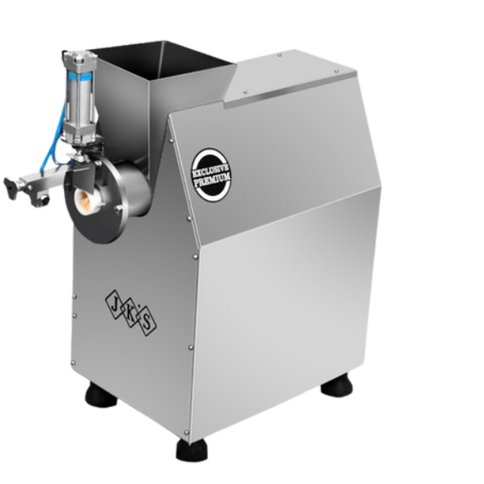
Electrical Specification
Technical Specification
The Machine Body Are Manufactured in Stainless Steel 304 (Food Graded Material.)
All The Mechanical Parts Of The Machines Are Made Up Of Aluminium Material. (Food Graded Material.) All Electric PLC Parts of Schneider Electric. (Made In Indonesia)
Internationally Standard Branded Electrical Panel Accessories. Electric Motor 1 HP (1 Nos)
Warm Gear Box (Made In Italy)
All Safety Features Available In Machine as Per Global Euro Standard

Page 07

Automatic Dough Kneading/ Mixing Machine

What this Machine Can Make
Dough

Machine Specification
Power | 1.5 KW
Voltage | 230 V / 50 Hz / Single Phase ( Can Be Customized According To Country- Wise Compatibility )

Machine Capacity | 5Kg To 50Kg Different Models
Cycle Time | 4 To 5 Minutes
Speed Of Machine | Fixed
Power Consumption | 1 Unit/Hour Approx

Machine Size & Weight

Machine Dimension | 36x19x32 Inches
Weight | 110 kg.

Durable
Machine Features
Easy to Operate Easy to Clean Corrosion Resistant

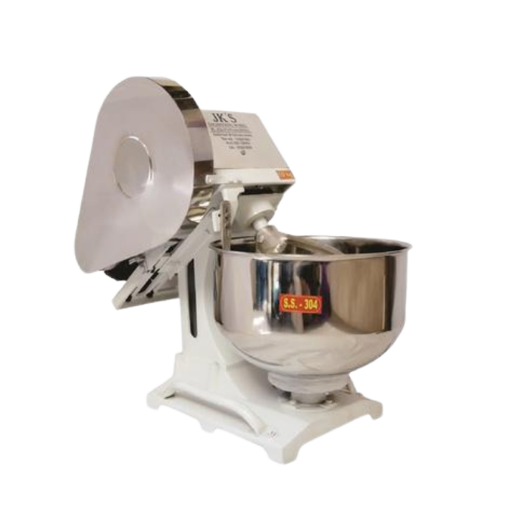
Electrical Specification
Technical Specification
The Machine Body Are Manufactured in Stainless Steel 304 (Food Graded Material.)
All The Mechanical Parts Of The Machines Are Made Up Of Aluminium Material. (Food Graded Material.) All Electric PLC Parts of Schneider Electric. (Made In Indonesia)
Internationally Standard Branded Electrical Panel Accessories. Electric Motor 1 HP (1 Nos)
All Safety Features Available In Machine as Per Global Euro Standard

Page 08



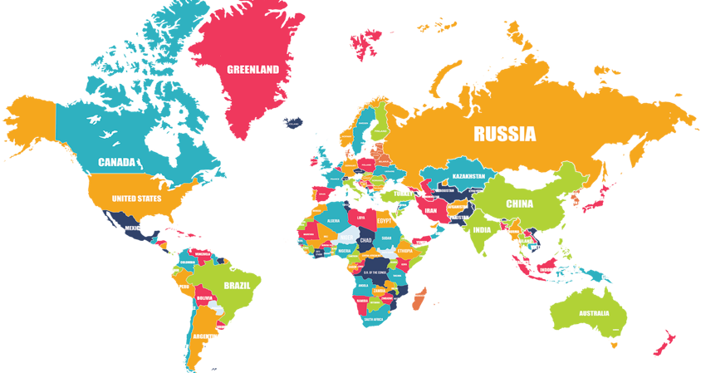
The Company Is CE-191561-EEPC CIN-AN ISO 9001:2015 Quality Management System Certified Company At Global Euro Accreditation Centre.

Get in Touch

Head Office: 1/6 Ved Vadi, Near. D-Mart Mall, Gondal Road, (Rajkot-360004- INDIA)

Factory Address: G-1123, Metoda GIDC ,
Gate No.3, Kalawad Road,(Rajkot-360021- INDIA)

+91 9824880034, +91 9924927006

sales@jksengworks.com jkseng.works@yahoo.com
www.jksengworks.com www.chapatimaker.in www.rotimakingmachine.in

