Press Release | January 2018

C-star 2018
Shanghai's International Trade Fair for Solutions and Trends all about Retail
Shanghai New International Expo Centre
Shanghai, China, 26 - 28 April 2018

Visitor Registration Now Open for C-star 2018

As the next edition of C-star is fast-approaching, online visitor registration has now officially opened. The organizers strongly encourage visitors to pre-register online to get the free ticket and ensure the smoothest show experience this April!

If you are planning your visit or thinking about participating in C-star 2018, you may visit www.c-star-expo.com to pre-register online and enjoy expedited access to all solutions and trends about retail! You will receive the confirmation letter after the registration.

Please bring along your name card and pre-registration confirmation letter (or registration number) to C-star, and check in at the pre-registration counter for an official visitor badge.
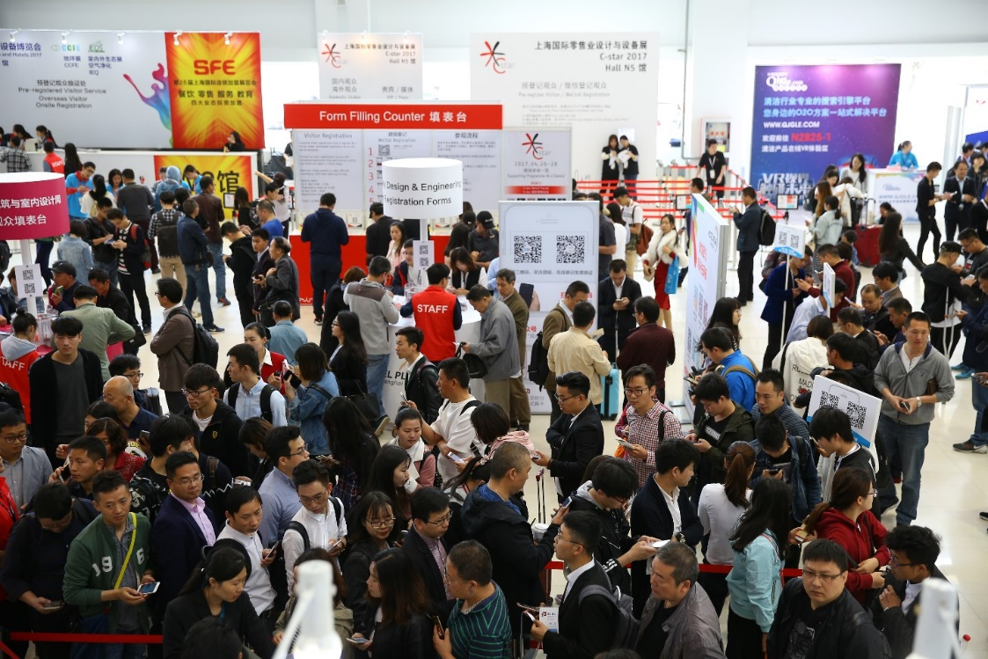

German Pavilion returns to showcase cutting-edge retail solutions

This year, the German Pavilion will again be featured to offer innovative retail products and solutions and global insights to C-star 2018. Exhibiting in this year’s German Pavilion are multi-nationals and foreign-owned enterprises set to showcase a diverse and international product range.

The German Pavilion is set to feature an exciting array of international products and retail solutions including digital-retail and 3D modeling software, POS displays and high-quality retail hardware and advanced retail fixtures from foreign-owned enterprises. Confirmed exhibitors for this year’s German Pavilion include Jiangmen Jiechu Hardware Fittings, VKF, TENTE, PYTHA and Bizerba etc.

Confirmed Speakers for C-star 2018 Retail Forum
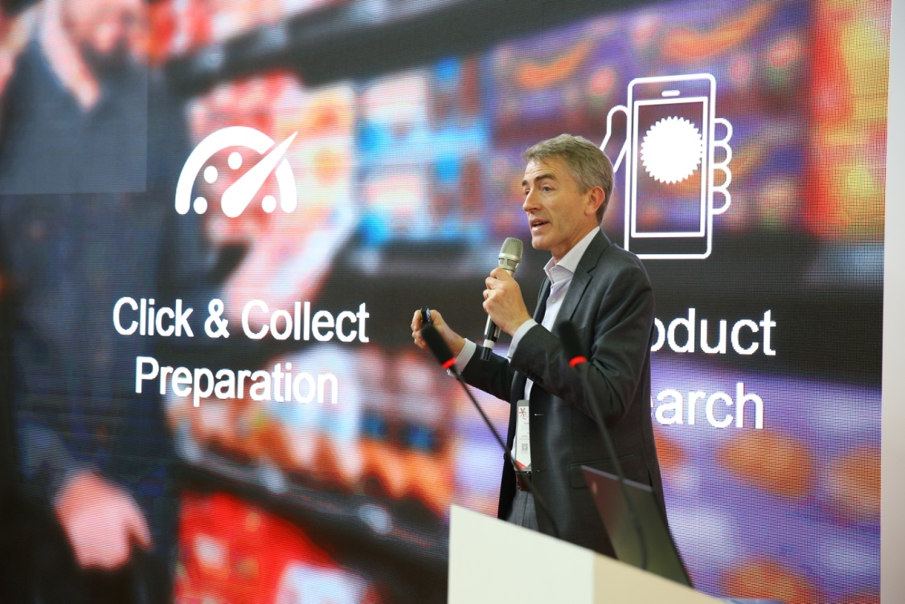
In 2018, C-star’s Retail Forum carries the theme of ‘Shape a Human Centered Retail World’, offering an open platform where industry experts and influencers, retail brand owners, shopping center operators, established commercial real estate developers, investors and other industry professionals can collectively discuss diversified themes including “global retail development trends", "The future of omnichannel retail", "consumption upgrade", and "space aesthetics". This premier platform offers an outstanding venue for industry professionals to gain new retail industry knowledge and to expand business networks.

C-star’s 2018’s Retail Forum will feature industry experts and authorities including Prof. Dr. Helmut Merkel – retail / retail services SME owner and European lifestyle product importer, Claudia Horbert - Director Research Store Planning & Design and Ulrich Spaan - Vice President of EHI Retail Institute, Akira Kajiwara - General Manager of China Region and Director of Design of GARDE, Wang Yue - Director and General Manager of Changhong Building Decoration Engineering Co., Ltd., Victor Guo - President of China Shopping Center Development Association of Mall China, Jaylin Cheng - director of MINISO Brand Center, Uchino Satoshi - Director of FUMKSS, Wang Wei – China Strategic Advisor of Australia Azurium (Shanghai), Wu Chuankun - Chairman of Guangdong Winshang Data Services Co., Ltd.

C-star Brand Zone 2018 – ideal platform to showcase your innovative product solution

C-star’s Brand Zone has served to be the premier stage to highlight new renowned and upcoming brands in the industry – an ideal platform for new and returning exhibitors to display their newest and most popular products to a professional industry audience. In 2017, enterprises like Bizerba, Shijiazhuang Changhong, Shopworks, Saneboon, Cityinno and Koscar showcased their newest shop concepts, space designs and smart retail equipment via the C-star Brand Zone, effectively promoting new and forward-thinking formats of business to eager spectators.

A series of activities and industry insights will be disclosed at the C-star Brand Zone. We invite visitors to stay-tuned and visit the C-star website often as the programme schedule will be published in February 2018.

More details about C-star brand zone, please contact Ms. Juliet Zhu at juliet.zhu@mds.cn.

For more details about C-star, please follow C-star Facebook as follows or visit the official website: http://www.c-star-expo.com/en/.

Follow C-star @ C-star Expo

- End –

Press Contact:
Ms. Renee Zhao
Messe Düsseldorf (Shanghai) Co., Ltd.
Tel: +86-21-6169 8335
Fax: +86-21-6169 8301
Renee.zhao@mds.cn
www.mds.cn

Organizers background information
Messe Düsseldorf (Shanghai) Co., Ltd.
Established in 2009, Messe Düsseldorf (Shanghai) Co., Ltd. (MDS) is a subsidiary of Messe Düsseldorf GmbH, one of the world’s top 5 exhibition organizers. MDS is committed to introducing world’s No. 1 trade fairs to China and to providing Chinese and international customers with superior exhibition services. MDS is successfully holding more than 20 leading trade fairs and conferences in China, covering the industries of printing, packaging, wire and tube, plastics, renewable energy, medical devices, retail, safety and health, wine & spirits and caravanning. MDS runs branch offices in Shanghai and Beijing with a workforce of some 70 full time employees. The worldwide outbound exhibition business (trade shows in Düsseldorf, Germany and other leading Messe Düsseldorf Global Shows) is organized by Messe Düsseldorf China Ltd. (MDC), serving Chinese exhibitors and visitors with superior customer service from its Hong Kong branch office. Find out more at www.mds.cn.

