THE 27TH SHANGHAI INTERNATIONAL HOSPITALITY EQUIPMENT & FOOD SERVICE EXPO (HOTELEX Shanghai 2018)
- THE MATCHMAKING GATEWAY TO THE BIG LEAGUE -

Hospitality and catering are closely correlated with each individual’s live – fascinate us more than ever. No matter the country or the region, socio-cultural revolutions of diversity are shuffling the game, and network building with matchmaking cooperation is the key metric for HOTELEX’s inimitable trademark.

HOTELEX Shanghai 2018 – A Full Sale Catering & Food Service Exhibition
A journey of a thousand miles begins with single step. With 26-year experience in hospitality and catering industry has equipped HOTELEX to become a leading series of catering equipment, supplies, and find food trade events in Shanghai, with its geo-adapt shows in Beijing, Chengdu, and Guangzhou, covering the value chain from Catering Equipment, Tableware to Catering Supplies, Fine Food, Beverage, Bakery & Ice Cream, Coffee & Tea, Wine & Spirits and Cooking Ingredients.
Once a year HOTELEX brings together buyers and suppliers from around the country to witness the latest trends in the industry and be inspired by leaders and legends in the field. To better serve the clientele in 2018 HOTELEX will be split into two phases held at the same venue located at Shanghai New International Expo Centre at different times.
HOTELEX 2018 – Phase I & II
Venue: Shanghai New International Expo Centre
HOTELEX Shanghai 2018 – Phase I
(THE 27TH SHANGHAI INTERNATIONAL HOSPITALITY EQUIPMENT & FOOD SERVICE EXPO)
Date: March 26 – 29, 2018
Exhibit Categories: Catering Equipment Supply, Tableware, Coffee & Tea, Wine & Spirits, Beverage, Cooking Ingredients, Ice Cream, Bakery
Concurrent: Expo Finefood 2018
HOTELEX Plus 2018 – Phase II
(Shanghai Hospitality Design & Supplies Expo)
Date: April 26 – 29, 2018
Exhibit Categories: Building, Interiors, Lighting, Amenities, Fitness & Leisure, IT & Security
Concurrent: Design Week Shanghai
Expo Lighting for Commercial Properties

A YEAR ON AND STILL IN THE PRESS
HOTELEX was a huge success according to the last year figures, 143,500 professional visitors and 2,352 premium exhibitors out in force, featuring a 6.6% increase in exhibitor amount and a huge leap of 22.3% in visitors in 2017. Total 4,814 independent overseas buyers from 124 countries and regions plus 1,500 group buyers confirmed both HOTELEX’s leadership and its influence on international markets, reflecting the extent to the expo competitiveness, and how the fair has helped forward-thinking industry players to meet the right people.
The level of innovation displayed by our exhibitors was second to none leaving with high scores at both visitor satisfaction and loyalty reaching 9 out of 10. Feedback has been overwhelmingly positive. Below are some exhibitor comments.
“It’s the 11th year our company attended HOTELEX, and what’s driven us is to present our innovative products” remarked by Patrick Xi, Vice President of North Asia, Welbilt Inc.

“Previous year we’ve always got a lot a few customer contacts that allow us to later on during the year sell the right and the best equipment to our customers and make them happy” from Christian Haueter, General Manager of Hospitality DKSH China

“We hope through HOTELEX, communication and sharing could be achieved with the integrated solution we’ve been accumulated in this industry. To us, the exhibition is indeed a predominant interaction opportunity” said Steven Zhang, Chairman of Shanghai Tonney Industrial Co., Ltd.

“Lots of my working partners and clients acknowledge also appreciate the value of HOTELEX, which is the most premium and professional exhibition so to speak” commented by Anne Cao, Director of Shanghai Ganbor Trading Co., Ltd.

“It’s a 14th year that Fabbri is present at HOTELEX. HOTELEX also accompanies us all around China because 5 years ago with HOTELEX organization we have founded the national Gelato Championship. This is the most important organization in China for the Gelato professionals” added by Nicola Fabbri, President of Fabbri.
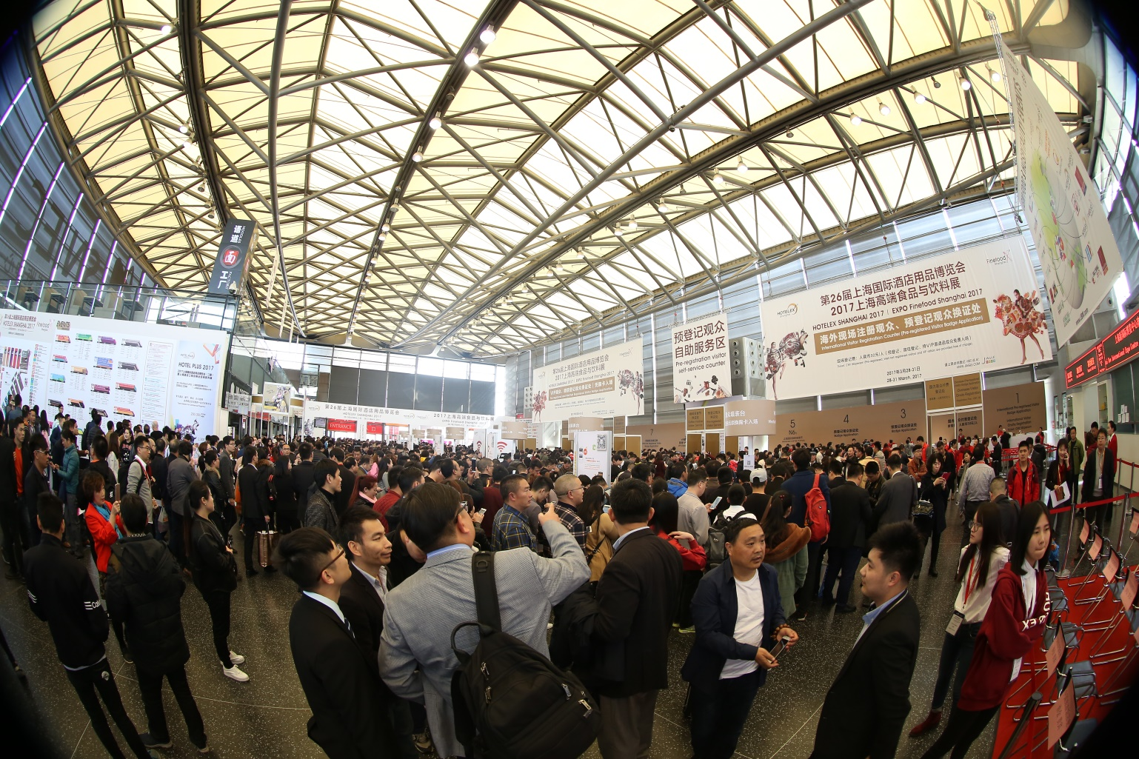

DECIPHER THE NEW CONSUMER’S PARADIGM
The economy hub of the country, Shanghai, has a large and growing population as well as multi-culture transformation led by international business and year-round tourism. The huge market is becoming increasingly sophisticated, and there is no doubt that food and hospitality are at the core of future developments. As the industry pioneer it’s the main task for HOTELEX defining its innovative role play in overcoming the 21st century challenge of adjusting to the current oscillating market while extending the vitality to an international level by liaising among government associations, chambers of commerce, social media and most paramount, the relationship between buyers and suppliers for a bright and promising future of the industry. How can we satisfy consumer expectations and deliver more? What influence does product innovation have on each market? What value do we bring to the industry?
Expert Keynote Line-up
Commercial kitchens are a minefield at the best of times; in this case it’s great to be able to get in front of those in the know, all in one place at the same time. Professional forums like 2017 HOTELEX Shanghai Innovation of Commercial Kitchen Design, Central Kitchen Construction and Development Forum, Development of China Catering Industry Supply Chain Forum, and HOTELEX Catering Industry Forum are set up for industry practitioners catching up with current suppliers and meeting new ones with the most front-line products being developed.
The expo targets the exact specifiers, buyers and food service operators including a significant number of purchasers from restaurants and pubs, hotels, caterers, attractions and institutes, as well as attracted an equally impressive turnout of all the key distributors, delegates, retail dealers, purchasing managers, etc.
Innovative Events and Championships
Designed to promote and encourage new ideas in the market place, HOTELEX had an amazing range of more than 30 “events within the event” helped to draw a record crowd, placing strategy at the heart of HOTELEX too. The show floor had a real buzz and exhibitors were accomplishing solid business as the onsite rebook rate for the next year was high. The show continues to deepen catering and hospitality knowledge by launching creative concurrent events and campaigns from catering field to hospitality area.
Events List:
Shanghai Coffee Festival, China Barista Championship, China Latte Art Championship, China Brewers Cup Championship, China Barista Championship, China Cup Tasters Championship, China Coffee Roasting Championship, WCE All Star, China Master Bartender Competition, Shanghai International Fashion Drinks Competition, World of Bread Contest China Selection, Shanghai Pizza Master Competition, “I’m The Chef” Shanghai Bakery Master Championship, “Kingdom Cup” Trophy of Pastry and Cake Design World Championship, World Pizza Championship China Division, China Gelato Championship, “Jinhong Cup” Star Hotel Table Art Display Competition, “Wanrun Cup” Star Hotel Service Skill Competition, HOTELEX “The Rising Star” chef Competition, HOTELEX & Sabor Fusion Star Chef Competition, Hotel Uniform, Art & Science kitchen Lab, Alibaba Import Platform In-Choice Live
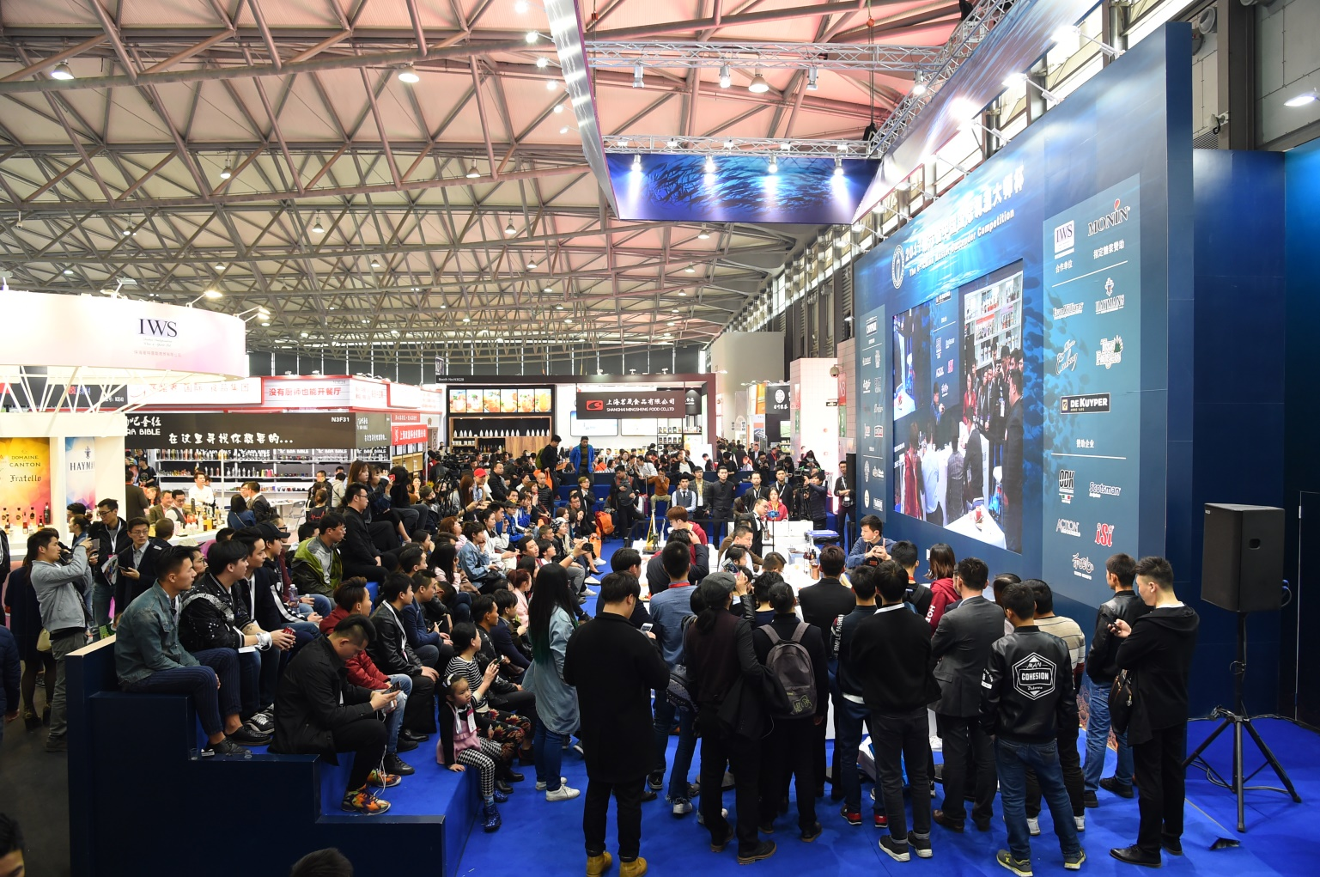

GATHER LATEST PRODUCTS AND INDUSTRY TREND UNDER ONE ROOF
Ever faithful to its principle “Be the Best”, HOTELEX has decided to move the section of hotel facilities and supplies to Hotel Plus – Phase II in April given the soaring growth results in concentrating on market segmentation in order to better serving the customer. To shine light on the most ground-breaking exhibition in the field and provide unparalleled media coverage, HOTELEX Shanghai 2018 – Phase I will be inaugurated with a pyramid of events paid tribute to the gastronomic specialties as well as the movers and shakers of the hospitality field.
The visitors are looking forward to the most exciting line-up of speakers and exhibitors and in return the exhibitors, wanting to impress the potential buyers and unmissable customers. The proof is in the pudding so to speak, positive results in matchmaking opportunities are always approved that HOTELEX gives exhibitors incredible extra visibility and expands media exposure. Have it out with industry players around the world and impress the world win the award. For those with an innovative product, HOTELEX as an unveiling platform can make a real difference.
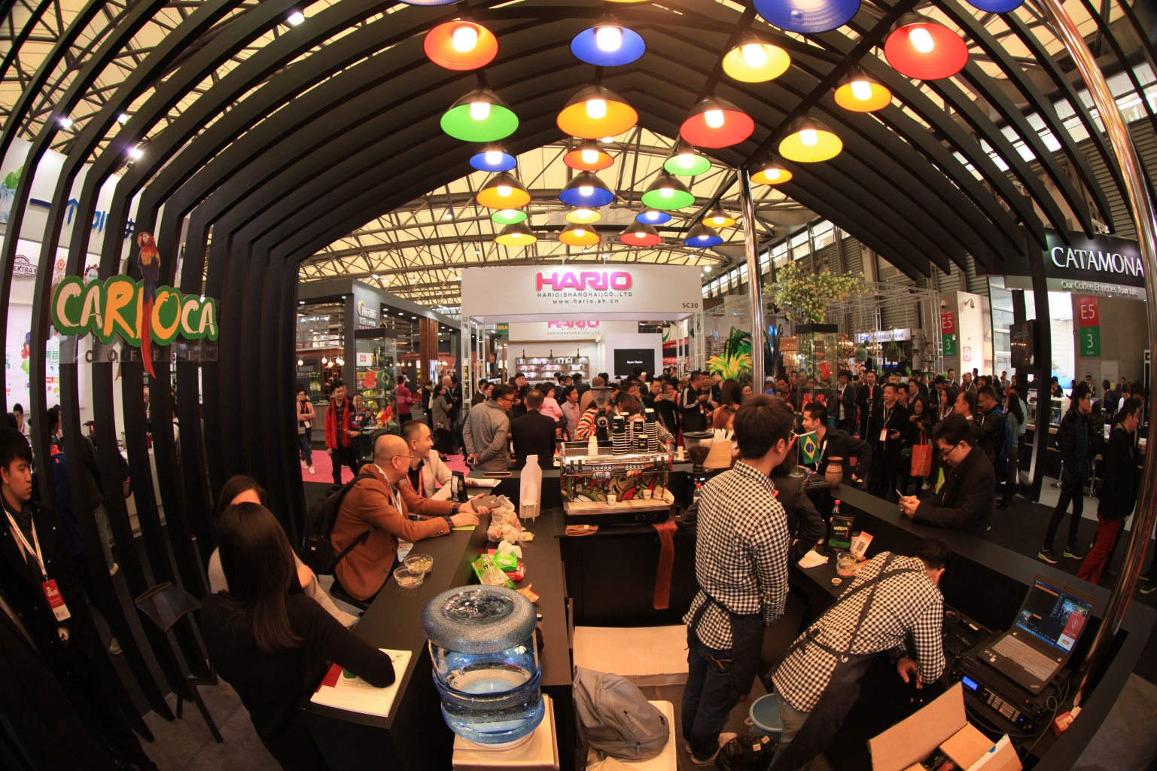
IT’S THE GATEWAY TO THE BIG LEAGUE
Looking back over the years to the starting point, the year of 2018 lands a chance on HOTELEX with infinite possibility and boundaryless innovation, a new journey will extend full of potential and will gradually lead us to the unlimited breadth of the realm and ultimately, find its way to combine you with us. It’s a free shot that proved too irresistible to pass up. There’s no better time than now, get yourself prepared, applications are free, registration is simple, grasp the valuable opportunity of presenting your products to increase visibility and kick-start networking with over 143,500 world players.
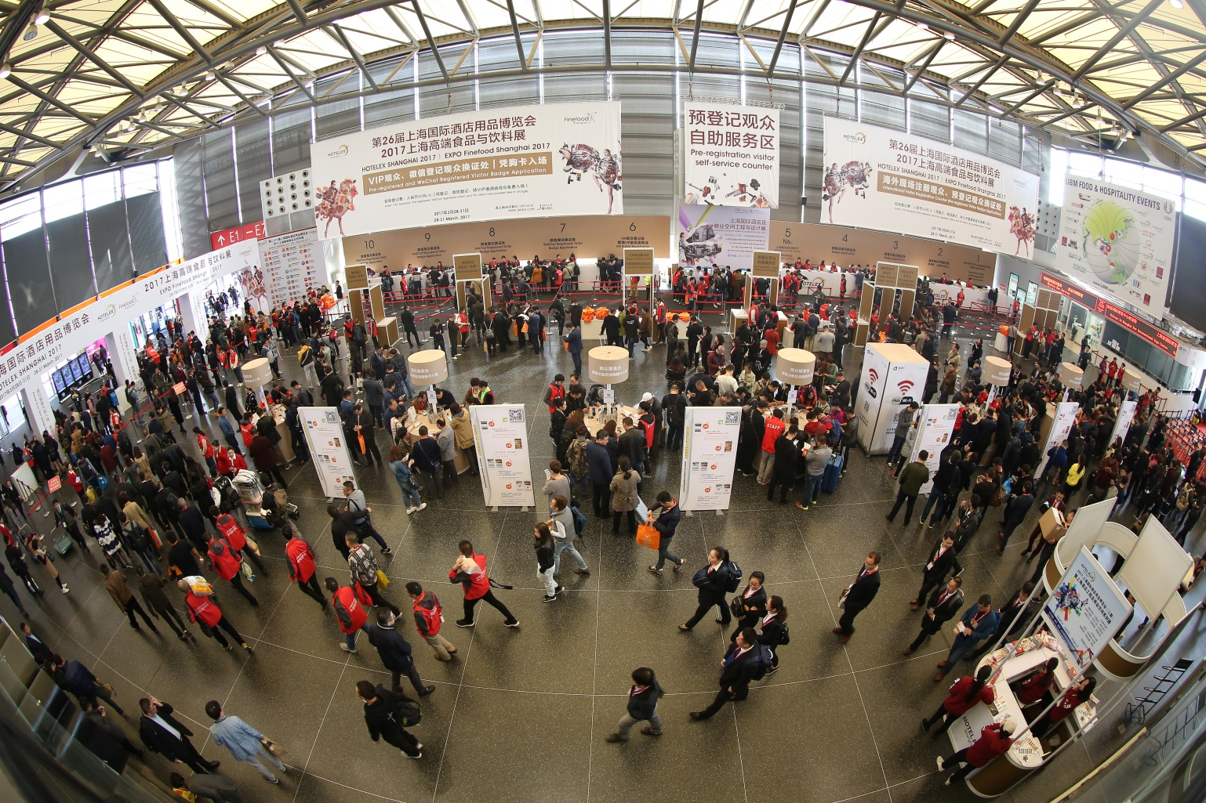
Stand bookings and visitor registration are now open. For more information on exhibiting or visiting please go to:
HOTELEX Shanghai 2018 – Phase I http://en.jiagle.com/hotelex-shanghai-exhibition/
HOTELEX Plus 2018 – Phase II http://en.jiagle.com/hotelex-shanghai2-exhibition/
Contact Info:
Alex Ni
Email: alex.ni@ubmsinoexpo.com
Tel: +86 21 3339 2242

Key Words: Matchmaking, HOTELEX Shanghai Exhibition, Hotel Plus, Catering & Food Service Exhibition

